# **# (Page) Home page**

1. Welcome to [Your Company Name]'s Education Management Software

Empowering Institutions | Enhancing Learning | Simplifying Administration.

1. Revolutionize Education Management with DigiEdu

Empowering institutions, educators, and students with seamless management and innovative tools.

1. Streamline Daily Operations, Unlock Insightful Reports, and Empower Smarter Decisions.

DigiEdu is an all-in-one online school management software designed to simplify and automate your institution's academic and administrative workflows with ease.

# **Call-to-Action (CTA):**

* Start Your Free Trial
* Request a Demo

# **# Why Choose Us Section:**

DigiEdu is a versatile school management system that effortlessly automates daily operations, delivers insightful reports, and offers 360-degree tracking. Empowering stakeholders with actionable insights, DigiEdu enables smarter, faster decisions to boost institutional productivity.

* **Intuitive Interface**: Designed for educators, administrators, and students alike.
* **Cloud-Based Convenience**: Secure access from anywhere, anytime.
* **Scalable Solutions**: Perfect for schools, colleges, and universities of all sizes.
* **Exceptional Support**: 24/7 customer support to ensure a smooth experience.

# **# Modules to Automate School Management or**

# **Key Features Section:**

* **Streamlined Administration**: Simplify operations with automated processes for admissions, scheduling, and communication.
* **Student Management**: Track progress, attendance, and performance effortlessly.
* **Customizable Curriculum Planning**: Design and manage courses tailored to institutional needs.
* **Real-Time Reporting**: Gain insights with detailed analytics and reporting tools.
* **Parent & Student Portals**: Foster collaboration with easy-to-use dashboards for students and parents.

# **# Perfect School Management System to Meet Your Institution Needs**

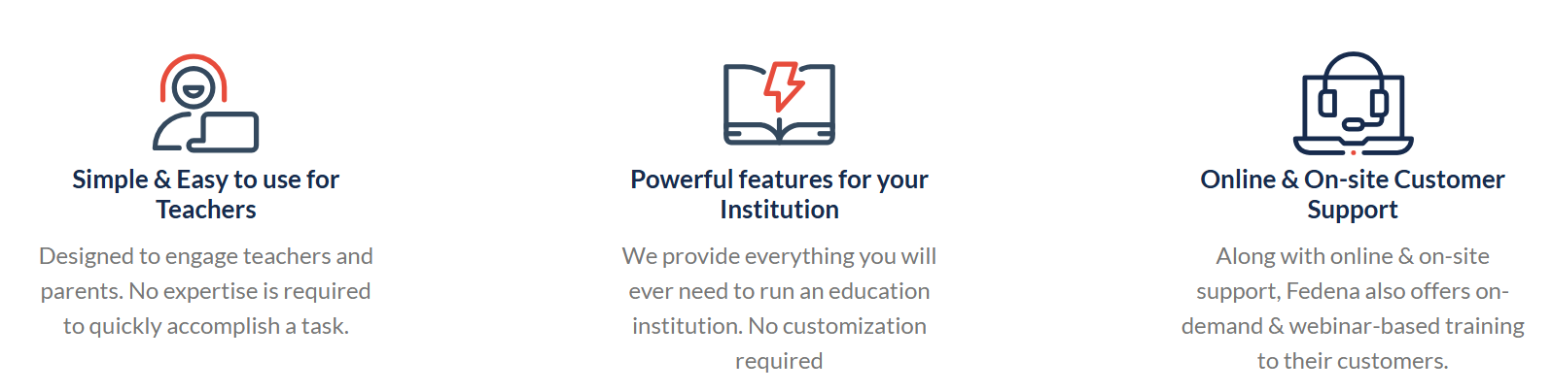

# **# Multiple Integration Options to Enrich Your School Management Experience**

Expand the capabilities of your school management system with a wide range of integrations designed to simplify operations, improve communication, and enhance overall efficiency.

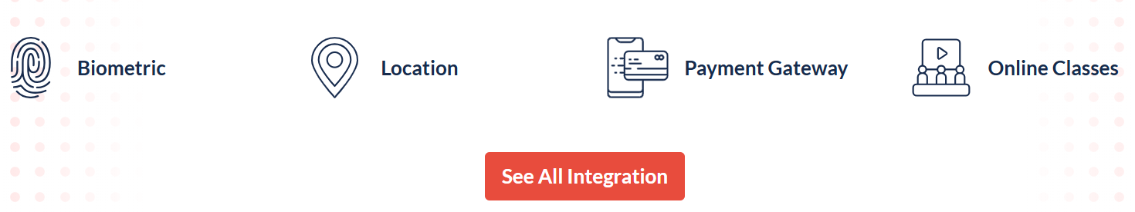

# **# Why Institutes Love DigiEdu School ERP System?**

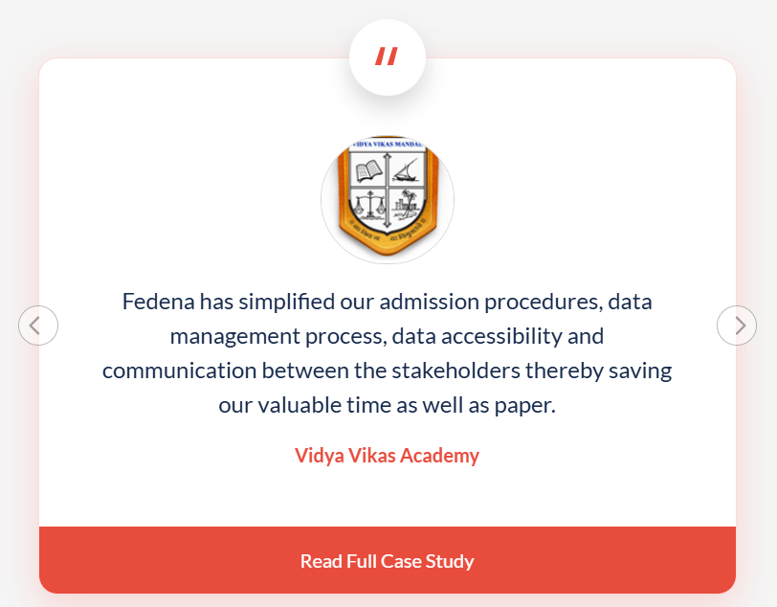

# **# FAQs on School Management Software**

**What is School Management Software?**

School Management Software is a digital platform designed to streamline and automate various administrative, academic, and communication tasks within educational institutions. It provides tools for managing admissions, attendance, schedules, grades, finances, and more, making the management process more efficient and less time-consuming.

**Why do institutes need School Software?**

**Institutes need school software to:**

* Streamline Operations: Automate routine tasks like attendance, fee collection, and scheduling.
* Improve Communication: Enable seamless interaction between parents, teachers, and administrators.
* Enhance Efficiency: Reduce manual workload, minimize errors, and save time.
* Track Progress: Provide real-time insights into student performance and institutional growth.
* Ensure Scalability: Manage growing student numbers and operations with ease.

**How can schools benefit from e-learning modules in School Software?**

**E-learning modules in school software offer several benefits:**

* Flexible Learning: Enable students to access lessons anytime, anywhere.
* Interactive Content: Enhance engagement through videos, quizzes, and gamified lessons.
* Personalized Learning: Tailor content to individual learning paces and styles.
* Efficient Evaluation: Automate assessments and provide instant feedback.
* Cost-Effective: Reduce the need for physical materials and resources.

**Who uses School Software?**

**School software is used by:**

* Administrators: For managing operations, finances, and reporting.
* Teachers: For lesson planning, attendance tracking, and grading.
* Students: For accessing assignments, schedules, and learning resources.
* Parents: To stay updated on their child’s progress and communicate with the school.

**How much does School Management Software cost?**

**The cost of school management software varies based on features, user capacity, and customization needs.**

* Basic Plans: Start at around $10–$50/month for small schools.
* Advanced Plans: Range from $100–$500/month, including premium features like analytics and integrations.
* Custom Enterprise Solutions: Tailored for large institutions and priced upon request.

**How do I choose School ERP?**

**To choose the right School ERP:**

1. Identify Your Needs: Understand your institution’s requirements and challenges.
2. Explore Features: Look for tools like student management, analytics, and communication portals.
3. Check Scalability: Ensure the software can grow with your institution.
4. User-Friendly Interface: Opt for intuitive and easy-to-navigate platforms.
5. Budget-Friendly Options: Compare pricing and features across vendors.
6. Customer Support: Prioritize solutions with strong technical support.
7. Reviews & Demos: Read user reviews and request demos before purchasing.

**What are the key features of School Management Software?**

* Student Information Management: Centralized data for easy tracking.
* Attendance & Scheduling: Automated tracking and timetable creation.
* Fee Management: Online payment gateways and financial reports.
* Parent-Teacher Communication: Notifications, portals, and messaging.
* Analytics & Reporting: Real-time performance tracking and insights.
* E-Learning Integration: Access to digital lessons and assessments.
* Mobile Access: Dedicated apps for administrators, teachers, parents, and students.

**Which is the best School Management Software?**

# **# (Page) Feature**

# **Students / Parents Login**

# **Features for Students:**

1. Dashboard
   * Overview of academic performance, attendance, and upcoming events.
2. Class Schedule
   * View daily, weekly, and monthly timetables.
   * Notifications for class changes.
3. Assignments & Homework
   * Access to assigned tasks with submission deadlines.
   * Option to upload completed assignments.
   * Feedback and grades on submitted work.
4. Exams & Results
   * Exam schedules and hall tickets.
   * View exam results and grades.
5. Attendance Tracking
   * Daily attendance reports.
   * Notifications for absenteeism.
6. Learning Materials
   * Downloadable resources like lecture notes, e-books, and videos.
   * Links to online learning platforms integrated with the software.
7. Communication Tools
   * Messaging system to interact with teachers.
   * Announcements from school administration.
8. Fee Details
   * View fee payment schedules and history.
   * Option to pay fees online.
9. Behavior and Discipline Reports
   * Updates on behavioral evaluations or disciplinary actions.
10. Extracurricular Activities
    * Participation records and schedules for clubs, sports, and cultural events.
11. Customizable Profile
    * Update personal information like contact details, profile photo, etc

# **Features for Parents:**

1. **Dashboard**
   * Summary of child’s academic progress, attendance, and fee status.
2. **Attendance Monitoring**
   * Real-time updates on child’s attendance.
   * Alerts for late arrivals or absences.
3. **Academic Progress**
   * Detailed performance reports for each subject.
   * Analysis tools like performance trends over time.
4. **Exam and Results**
   * Access to child’s grades, test results, and feedback from teachers.
5. **Homework & Assignments**
   * View assigned homework and submission deadlines.
   * Notifications for overdue tasks.
6. **Fee Management**
   * View pending fees and due dates.
   * Online fee payment with downloadable receipts.
7. **Behavior & Discipline Tracking**
   * Alerts and reports on behavioral performance.
   * Notes on disciplinary actions or commendations.
8. **Communication Tools**
   * Chat or messaging functionality to connect with teachers or administrators.
   * Notifications about school events, policies, and announcements.
9. **Event Participation**
   * Updates on parent-teacher meetings, school events, and extracurricular activities.
10. **Transport Tracking**
    * Real-time tracking of school buses.
    * Notifications for delays or route changes.
11. **Sibling Management**
    * Unified dashboard for parents with multiple children in the school.
12. **Health Records**
    * Updates on child’s medical conditions, vaccinations, or incidents at school.
13. **Parent Feedback**
    * Option to provide feedback or suggestions to school management.

These features ensure smooth communication between schools, students, and parents while improving transparency and collaboration for the child's academic journey.

# **Student Information System (SIS)**

A **Student Information System (SIS)** is a comprehensive software solution designed to manage and streamline all aspects of student-related data within educational institutions. Below are some common features of a robust SIS:

**1. Student Enrollment and Registration**

* **Online Enrollment**: Allows students to register for courses or programs.
* **Admission Management**: Handles application forms, document uploads, and admission decisions.
* **Fee Tracking**: Facilitates payment of tuition and other fees with tracking options.

**2. Academic Management**

* **Course Management**: Organizes courses, credits, prerequisites, and syllabi.
* **Timetable Scheduling**: Automated creation of class schedules and room assignments.
* **Attendance Tracking**: Tracks student attendance and generates reports.

**3. Gradebook and Assessment**

* **Grade Management**: Records and calculates grades for assignments, exams, and overall performance.
* **Progress Tracking**: Provides dashboards for academic progress and GPA.
* **Exam Scheduling**: Manages exam timetables and seating arrangements.

**4. Student Profile Management**

* **Personal Information**: Stores demographic data, contact details, and emergency contacts.
* **Academic Records**: Maintains transcripts, certifications, and course history.
* **Behavioral Records**: Tracks disciplinary actions or achievements.

**5. Communication and Collaboration Tools**

* **Parent/Guardian Access**: Provides portals for parents to monitor student progress.
* **Messaging System**: Facilitates communication between students, teachers, and administrators.
* **Announcements and Notifications**: Delivers updates on events, grades, or important deadlines.

**6. Administrative Functions**

* **Staff Management**: Manages teacher and staff profiles, schedules, and workloads.
* **Library Management**: Tracks borrowing, inventory, and overdue books.
* **Transport Management**: Organizes routes, stops, and vehicle assignments for students.

**7. Reporting and Analytics**

* **Custom Reports**: Generates reports on attendance, grades, admissions, and more.
* **Data Insights**: Provides analytics on student performance and institutional efficiency.
* **Compliance Tracking**: Ensures adherence to accreditation standards and policies.

**8. Financial Management**

* **Billing and Invoicing**: Tracks student payments, generates bills, and issues receipts.
* **Scholarships and Financial Aid**: Manages applications and disbursements.
* **Budget Tracking**: Monitors departmental expenses related to students.

**9. Integration and Security**

* **Third-Party Integration**: Links with other platforms like Learning Management Systems (LMS), payment gateways, and HR systems.
* **Data Security**: Ensures secure storage and access of sensitive student information.
* **Access Control**: Role-based permissions for students, faculty, and administrators.

**10. Mobile Accessibility**

* **Mobile App**: Enables students and staff to access the system on smartphones and tablets.
* **Push Notifications**: Delivers instant alerts for updates or deadlines.

A well-implemented SIS improves efficiency, enhances communication, and supports decision-making across educational institutions. Let me know if you'd like more details on any specific feature!

**OR**

**Benefits of a Student Information Management System**

Manually managing student data can often be a tiresome and time-consuming task for educators and administrators. However, with advancements in education technology, institutions can now streamline operations, improving student productivity, efficiency, and outcomes.

A **Student Information System (SIS)** allows educational institutions to efficiently manage vast amounts of student data in a centralized and secure manner, providing a cost-effective solution to administrative challenges.

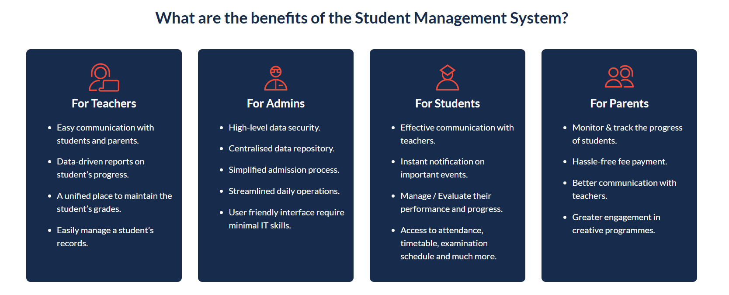

# **Certificate Generator**

A **Certificate Generator** in school management software simplifies the process of creating, customizing, and distributing certificates for various purposes. This feature is especially beneficial for schools, as it saves time, maintains professionalism, and ensures consistency across all issued certificates. Here are the key features of such a system:

**Certificate Generator Features in School Management Software**

* + Use field codes to dynamically insert system data (e.g., student names, roll numbers, grades) or custom data (e.g., event details, award titles) directly into certificates.
  + Add personalized backgrounds for certificates to align with school or event themes.
  + Include recipient photos, barcodes, or QR codes for added customization and security.
  + Easily create and edit templates for students, employees, or specific events using a built-in Rich Text Editor.
  + Customize fonts, layouts, logos, and other design elements to meet institutional branding needs.
  + Generate certificates for individual and multiple users at once for events, graduations, or participation.

# **Attendance Management System**

**1. Attendance Tracking: Subject-wise or Day-wise**Customize the attendance type based on institutional preferences. Attendance can be recorded either subject-wise or day-wise. Teachers can easily mark attendance for a half-day or full day with or without specifying reasons, all in a single click.

**2. Latecomer Tracking and Leave Requests**Utilize the custom attendance feature to track latecomers effectively. Employees can also submit leave requests in case of emergencies directly through their DigiEdu account. Managers are instantly notified and can approve or deny leave requests with ease.

**3. Employee Attendance and Leave Management**Efficiently monitor employee attendance and leave records. Seamless integration with payroll ensures an automated process, significantly reducing manual errors and streamlining payroll management.

**4. Comprehensive Reporting**Admins can effortlessly generate detailed reports such as day-wise or batch-wise student attendance and leave summaries. Digital data storage within DigiEdu minimizes paper waste and simplifies access to information.

**5. Biometric Integration for Accurate Tracking**  
Integrate with Biometric and RFID devices to automate attendance data collection. This eliminates the risk of proxy attendance and provides real-time monitoring of student movements within the premises.

# **Admission Management**

**Optimized Admission Process**

* **Digital Verification & Fee Collection:** Verify original documents digitally and collect admission fees with just a click.
* **Automatic Batch & Subject Allocation:** Seamlessly assign students to batches and subjects for each academic year.
* **Customizable Admission Forms:** Tailor admission forms to meet your institution’s specific requirements.
* **Integrated Communication:** Set up immediate student-related contacts and automate emails/SMS notifications accordingly.
* **Timely Updates:** Keep parents and students informed about admission test dates, results, and other key updates.

**Centralized Data Management**

* **Comprehensive Student Records:** Maintain academic records for all students, including alumni, in one place.
* **Digital Document Storage:** Save essential student and employee documents in digital formats for easy access.
* **Employee Data Management:** Store all employee details and records securely in one system.
* **Custom Report Generation:** Generate tailored reports with any student or employee profile information and manage access permissions.
* **Additional Data Storage:** Add and save extra details for both students and employees effortlessly.

# **Human Resource System**

**Centralized Employee Management:** Manage all employee details, including personal data, leave records, payroll, and payslip generation, on a single platform.

**Customizable Data Upload:** Use a customizable admission form to upload employee details efficiently in one go.

**Bulk Import Functionality:** Quickly upload employee data using the bulk import option, saving significant time.

**Flexible Payroll Setup:** Configure payroll settings to account for variations in earnings and deductions with ease.

**Instant Payroll Updates:** Support instant changes in payroll amounts whenever needed.

**Data Recovery:** Retrieve archived employee details seamlessly in case of accidental deletion.

**Payslip Generation:** Employees with the necessary privileges can generate payslips based on their assigned payment frequency.

**Batch Payroll Assignment:** Assign payroll collectively to employees with similar pay structures and frequencies.

**Approval Workflow:** Define independent privileges for approving, rejecting, or regenerating payslips for employees.

**Advanced Reporting:** Configure payslip report settings and generate leave balance reports for specific durations.

**Integrated Loss of Pay Deductions:** Automate loss-of-pay calculations directly within the employees’ payslips for accurate deductions.

# **Gradebook and Examination Management System**

**1. Examination Planning and Scheduling**

* Create and manage exam schedules for different classes, batches, or groups.
* Set exam types (term, unit test, final exams) and grading criteria.
* Automate timetable generation for exams to avoid conflicts.

**2. Customizable Grading System**

* Configure grading scales such as percentage, GPA, or letter grades.
* Define institution-specific grading criteria and weightage for each subject or assessment.
* Support for cumulative and non-cumulative grading methods.

**3. Question Paper Management**

* Digitally create, store, and distribute question papers.
* Maintain a secure repository to prevent unauthorized access.
* Categorize question papers by difficulty level, subject, and exam type.

**4. Online and Offline Exam Support**

* Conduct exams online with features like timed submissions and plagiarism checks.
* Integrate offline exam results into the system for a unified gradebook.

**5. Attendance and Exam Eligibility**

* Monitor attendance to ensure students meet eligibility criteria for exams.
* Generate automated alerts for students falling below attendance thresholds.

**6. Gradebook Creation and Management**

* Automatically generate gradebooks based on student performance.
* Include detailed breakdowns of scores, grades, and teacher comments.
* Support for subject-wise, term-wise, and overall performance reports.

**7. Analytics and Performance Insights**

* Provide graphical and statistical analysis of student performance.
* Identify trends, strengths, and areas for improvement.
* Generate comparative reports for individuals, classes, and batches.

**8. Parent and Student Access**

* Allow parents and students to access grades, reports, and teacher feedback online.
* Send notifications for upcoming exams, results, and performance reviews.

**9. Result Generation and Publishing**

* Automate result compilation with features like pass-fail calculations.
* Publish results online with options for secure login access.
* Generate customizable report cards in digital or printable formats.

**10. Integration with Other Systems**

* Seamlessly integrate with attendance, fee management, and student information systems.
* Link grades to promote students automatically to the next academic level.

**11. Security and Role-Based Access**

* Implement role-based permissions for teachers, admins, and students.
* Ensure secure handling of sensitive data such as exam results and grades.

**12. Feedback and Remedial Actions**

* Include teacher feedback for student performance.
* Identify low-performing students and plan remedial sessions or activities.

1. **Teacher-Friendly Tools**

* Flexibility for teachers to input, edit, and update marks whenever necessary.

This system simplifies the management of exams and grades, offering a streamlined, efficient, and transparent process for educators, administrators, and students.

# **School Timetable Management System**

**1. Simplified Timetable Scheduling**

* Effortlessly create and manage timetables for all classes and terms.
* Pre-set timetables in advance for seamless academic planning.

**2. Customizable Class Timings**

* Define multiple timing sets for different types of periods or activities.
* Easily adapt to varying schedules across different grades or departments.

**3. Subject and Teacher Allocation**

* Assign subjects to teachers efficiently based on their availability and expertise.
* Enable teachers to access their personalized timetables through their login portals.

**4. Student Timetable Access**

* Allow students to view their weekly or daily timetables, ensuring better preparation and time management.

**5. Classroom Allocation Management**

* Streamline classroom assignments to avoid conflicts and ensure optimal resource usage.

**6. Timetable Reporting**

* Generate institutional timetable reports for analysis or display on notice boards.
* Provide a clear overview for administrative review or communication with stakeholders.

**7. Real-Time Notifications for Changes**

* Instantly notify teachers about any timetable swaps or updates to ensure smooth execution.

This system simplifies scheduling, enhances transparency, and ensures efficient utilization of institutional resources for both staff and students.

# **Account Management Features**

**1. Fee and Payroll Notifications**

* Receive instant notifications for fee payments and payroll entries, keeping all stakeholders informed.

**2. High-Level Data Security and Storage**

* Ensure data is securely stored with high-level encryption to protect sensitive financial information.

**3. Efficient Expense and Income Management**

* Effectively track and manage total expenses and income, providing a clear overview of the institution's financial health.

**4. Daily Transaction Details**

* Access a detailed view of daily transactions for better financial tracking and reporting.

**5. Asset, Liability, and Expense Management**

* Seamlessly manage assets, liabilities, and expenses for comprehensive financial oversight.

**6. Printable General Vouchers**

* Generate printable general vouchers for easy documentation and record-keeping.

**7. Fee Receipts, Bank Slips, and Salary Slips Generation**

* Automatically generate fee receipts, bank slips, and salary slips for streamlined administrative processes.

**8. Cheque Reports**

* Generate detailed cheque reports for easy tracking of payments made and received.

**9. Outgoing Cheque Register**

* Maintain a register for outgoing cheques, ensuring accurate financial record-keeping.

**10. Personal Ledger Report Generation**

* Generate personal ledger reports for detailed financial analysis of individuals or specific accounts.

This system provides a robust framework for managing finances, offering both security and efficiency for daily operations.

# **ID Card Generator**

Designing an ID card for students, staff members, and visitors like a pro with minimal time and effort can only be achieved by DigiEdu ID card generator module. As ID cards do enhance not only the security of the institutes but also provide full control over the design and production process.

**Features of ID Card Generator in School ERP**

**1. Customizable ID Card Design**

* Design ID cards with customizable templates to include school logo, colors, and layout preferences.
* Easily add student, staff, or faculty details like name, photo, class, and role.

**2. Bulk ID Card Creation**

* Generate ID cards for large groups of students, teachers, or staff in bulk, saving time and effort.
* Import data from the school database to create multiple ID cards at once.

**3. Barcode and RFID Integration**

* Add barcodes or RFID tags to ID cards for easy tracking, attendance marking, or library management.
* Enable scan-based access control and tracking within the school premises.

**4. Photo Integration**

* Automatically capture or upload student, staff, or faculty photos for ID card inclusion.
* Ensure accurate and up-to-date images are displayed on ID cards.

**5. Security Features**

* Include security elements like QR codes, holograms, or digital watermarks to prevent fraud.
* Customize ID cards with unique serial numbers to track and authenticate each card.

**6. Print-Ready Format**

* Generate ID cards in a print-ready format (e.g., PDF or image files).
* Ensure high-quality output for professional printing.

**7. Role-Based Access and Information**

* Customize the details shown on the ID card based on the role (e.g., student, teacher, or staff).
* Include specific information such as class, section, or department.

**8. Expiry Date and Renewal Alerts**

* Set expiration dates for ID cards and automate reminders for renewals or re-issuance.
* Track issued cards and expired IDs to maintain up-to-date records.

**9. Easy Access and Management**

* Access and manage the entire ID card database from the ERP system.
* Retrieve and print specific ID cards as needed for new students or staff.

**10. Multi-User Access**

* Allow different levels of access to the ID card generation tool (e.g., admin, registrar, or support staff).
* Ensure data security and appropriate usage by limiting access based on roles.

This ID Card Generator feature in the School ERP streamlines the creation, management, and security of identification cards for students, staff, and faculty, ensuring smooth and efficient operations.

# **Library Management**

Structured list of features for a **Library Information Management System** with barcode integration:

**Key Features:**

* Streamlines book management through barcode scanning.
* Speeds up book issue and return processes.
* Centralized repository to organize and manage all book details.
* Easy addition, updating, and removal of books from the system.
* Complete tracking of issued and renewed books.
* Automated alerts for overdue books.
* Logs for borrowing history of each user.
* Allows students to search for books and view availability in real-time.
* Facilitates online book issue and renewal requests.
* Generate lists of books issued or due within specific time frames.
* Reconcile and audit book inventory seamlessly.
* Export book and inventory details in CSV format for backup or analysis.
* Create and manage digital fine receipts for overdue books.
* Track fine collections and generate detailed reports.
* Generate customized reports for library inventory, issued books, overdue books, and fine collection.
* Visual insights into library usage and trends.

These features make the system efficient and enhance user experience for both students and librarians.

# **News/Notification Management Features**

**Key Features:**

**1. News Creation**

* Create engaging news posts using rich text, images, videos, and other multimedia.
* Intuitive editor for formatting and enhancing content.

**2. News Publishing**

* Administrators can publish news specifically targeted at employees, students, or both.
* Options to schedule news for future publishing.

**3. Attachments**

* Add multiple attachments (e.g., PDFs, images, or documents) to provide additional context or detailed information.

**4. Interaction and Comments**

* Enable users to comment on news posts for feedback or discussions.
* Facilitate collaboration and engagement within the school community.

**5. Comment Moderation**

* Administrators have full control to moderate and approve comments before they are visible.
* Prevent inappropriate or irrelevant comments to maintain a professional environment.

**6. Accessibility and Notifications**

* Instant notifications to users about newly published news.
* Mobile-friendly access for ease of use across devices.

These features make the system effective for creating, sharing, and managing news while fostering interaction within the school community.

# **SMS Integration in School Management System**:

**Key Features:**

**1. Automated Notifications**

* Send **automatic alerts** to users (students, parents, and staff) for specific events, such as:
  + Fee due reminders.
  + Exam schedule announcements.
  + Attendance updates.
  + Event reminders or changes.
  + Emergency notifications.

**2. Manual Messaging**

* Administrators and employees can manually send SMS messages to:
  + Other employees.
  + Students.
  + Parents.

**3. Customizable Settings**

* **SMS Template Configuration**: Create and save message templates for common notifications.
* **Targeted Messaging**: Send messages to specific groups, such as a batch, class, or individual.

**4. User-Friendly Integration**

* Seamlessly integrated into the school ERP system.
* Easy access to the SMS module for instant communication.

**5. Personalized Communication**

* Include personal details (e.g., student name, roll number, or event specifics) in SMS messages for better relevance.

**6. Mobile Alerts**

* Deliver SMS alerts directly to the mobile phones of all users, ensuring timely communication.

This SMS integration feature enhances communication efficiency, keeps stakeholders informed, and promotes better engagement within the school community.

# **Inventory In School ERP**

**Key Features:**

**1. Indent and Purchase Management**

* **Raise Indents**: Employees can raise indents for required items seamlessly.
* **Manage Purchasing**: Track and process purchase orders efficiently.

**2. Inventory Tracking**

* Maintain a complete record of the inventory management process, from item requests to delivery.
* Monitor stock levels and track usage trends to prevent shortages or overstocking.

**3. Store Management**

* **Add Stores and Items**: Create and organize multiple stores and their respective items within the ERP.
* **Centralized Management**: Store managers can oversee and manage all inventory operations from a single interface.

**4. Purchase Order Management**

* Generate and manage **purchase orders (POs)** for item procurement.
* Track PO statuses, from creation to approval and fulfillment.

**5. Goods Receipt and Invoice Generation**

* **Create GRN Notes**: Generate **Goods Received Notes (GRN)** to document item receipts.
* **Invoice Management**: Create, review, and track invoices for purchased items.

**6. Employee Collaboration**

* Allow employees to raise requests (indents) for inventory items whenever required.
* Ensure transparent communication between staff and the store manager.

These features ensure efficient inventory operations and streamline the procurement process, enhancing resource management within the institution.

* শিক্ষক, শিক্ষার্থী এবং অবিভাবকগণ পাবেন নোটবুক বা ডায়রি সুবিধা। যেটি ব্যবহার করে শিক্ষকরা তাদের প্রতিদিনের বিষয়ভিত্তিক ক্লাসের পড়া টাইপ করে লিখে অথবা খাতায় লিখে ছবি তুলে আপলোড দিতে পারবেন। যাহা শিক্ষার্থী এবং অবিভাবকগণ অতি সহজেই ''Student App''- এর মাধ্যমে ঘরে বসেই প্রতিদিনের বাড়ির কাজ দেখতে পারবে।

# **# (Page) Custom-built School Management Software**

**Tailored Solutions to Fit Your Institution's Needs**

Experience the perfect blend of simplicity and functionality with our school management software, backed by the expertise and reliability of a professional service team. We understand the importance of having dedicated support at every step, ensuring your success. That’s the promise of the DigiEdu Enterprise package—designed to meet your unique requirements.

**Collaborating with the Best**

The DigiEdu Enterprise experience is supported by a carefully selected team of experts dedicated to your success. Our all-star team will help you set ambitious, transformational goals for your educational institution and ensure you achieve them. This isn’t just a promise—it’s a lasting partnership focused on delivering exceptional customer support and measurable results.

**Elevate Your Growth to the Next Level**

With the Fedena Enterprise package, you gain more than just software—you gain a team of dedicated professionals supporting you every step of the way. Behind the code, we’re here to ensure your success at all times.

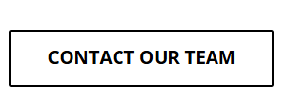

# **# (Page) Case Studies**

**Powered by DigiEdu Enterprise**

Trusted by thousands of prestigious institutions worldwide, DigiEduserves as the go-to ERP software suite. It empowers schools to achieve ambitious goals in student management, financial management, human resource management, and data analytics.

* Case studies of Madrasha
* Case studies of CZM school

# **# (Page) Integration**

**Conference App Integration**

With DigiEdu-Video Conferencing Integration, institutes can seamlessly conduct online classes, web meetings, and real-time events. This feature ensures educators and students stay connected, enabling uninterrupted learning and collaboration.



* **Payment Gateway Integration**

**Streamline Payment Collection with Ease**

DigiEdu's Payment Gateway Integration ensures a faster and more reliable cash flow for institutions. Parents can conveniently pay fees online anytime, from anywhere. This feature eliminates manual reconciliation and provides detailed transaction reports for seamless financial management. Click the button below to explore available options for Payment Gateway Integration.

* **GPS Integration**

**GPS Integration for Enhanced Fleet Management**

DigiEdu's GPS Integration provides a comprehensive overview of the entire fleet management system. It enables parents and staff to track school buses in real-time, ensuring the safety and security of students during their commute to and from the institution.

* **Communication Integration**

**Simplified Communication with Bulk SMS Service**

DigiEdu's in-built bulk SMS service streamlines communication between parents, teachers, and students. With DigiEdu SMS integration, institutions can instantly send text messages and notifications about upcoming events and activities, ensuring timely and effective updates for all users.

* **Biometric Integration**

**Effortless Attendance Management with Biometric Integration**

DigiEdu's Biometric Integration automates attendance data collection, eliminating the risk of proxy attendance and storing data in real time. Administrators can effortlessly track attendance and access all records on a single platform, ensuring accuracy and efficiency.

# **# (Page) About**

* Our Team
* Our customers
* Award and Recognition
* Career

# **# (Page) Pricing**

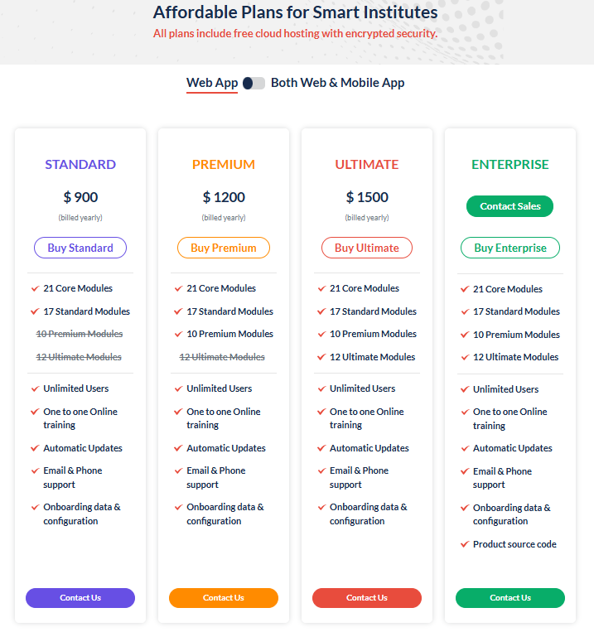

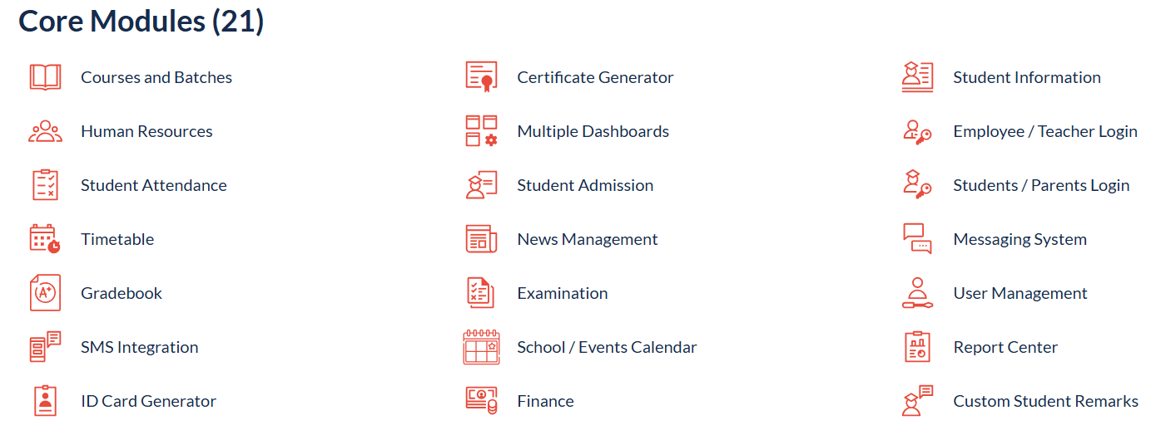

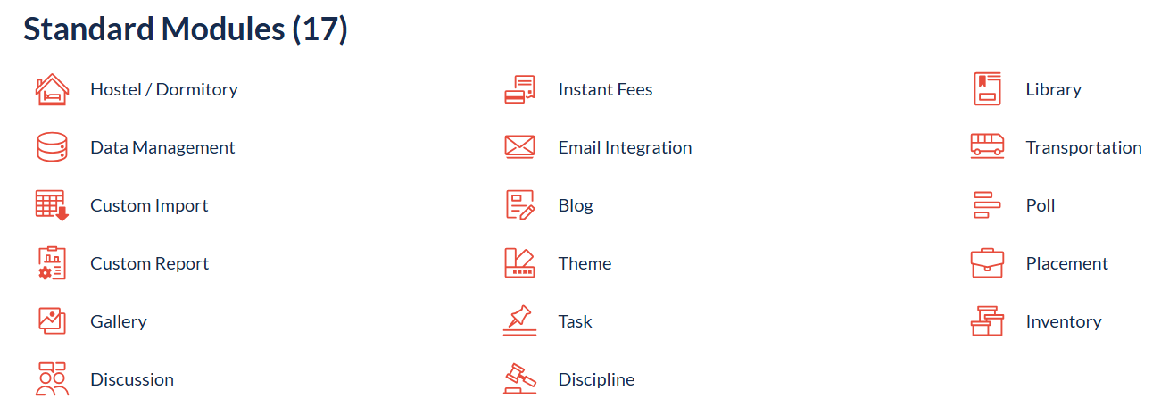

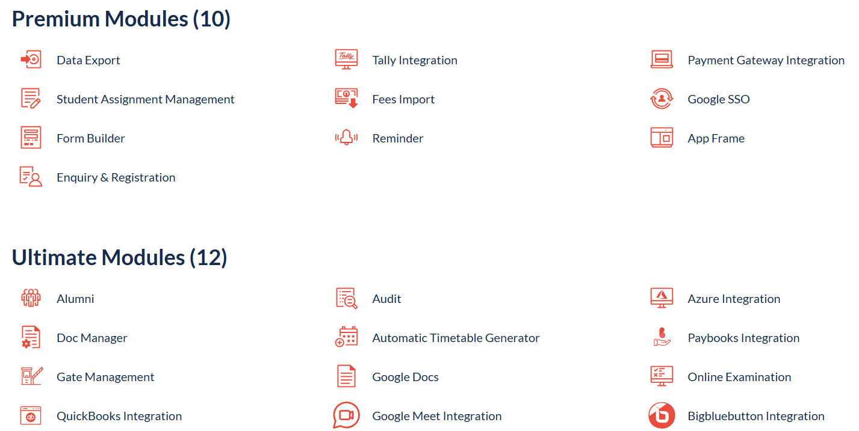

[**https://school360.com.bd/**](https://school360.com.bd/)

**[Desh Universal Private Limited](https://deshuniversal.com/)**

[**https://addiesoft.com/**](https://addiesoft.com/)

**(অধ্যায়ন নামে সফটওয়ার চালু, ৩০০ বেশি স্কুল কাভারেজ আছে। ভাল কিছু স্কুল কাভার করেছে। কিন্তু মনে হয় এখন তাদের)**

May be included in the soft

* Bangla and English both medium needed.
* Adons (uniform and Stationary etc)
* Mobile Friendly

**যা করতে হবেঃ**

* প্রথমে ওয়েবসাইট টা কমপ্লিত করতে হবে।
* একজন কনসালটেন্ট দিয়ে সামগ্রিক সফটওয়্যারের এর ওপর একটা বিজনেস প্রপোজাল বানাতে হবে। সেক্ষেত্রে নিপু নুর বিল্লাহ কে দায়িত্ব দেয়া যেতে পারে। ২০০০০ টাকা খরচ করা যেতে পারে।
* একটা সফটওয়্যার এর ডেমো ভিডিও বানাতে হবে।
* একটা কম্প্রিহ্যন্সিভ লিফলেট/ব্রশিয়ার বানাতে হবে।
* সফটওয়্যার এ একটা ডেমো স্কুল তৈরি করতে হবে, যাতে কোথাও প্রেজেন্টেশনের সময় কাজে লাগে।